**UNDERSTANDING THE CAREER ASPIRATIONS OF GENZ**

This project was a virtual internship at KultureHire, focused on understanding the career aspirations of Gen-Z. The project involved a comprehensive study to identify how the career preferences of Gen-Z differ from previous generations due to technological, societal, and economic changes. The aim was to provide essential insights for educational institutions, employers, policymakers, and career counselors to support this demographic effectively. Given the urgent need to address these aspirations as more Gen-Z individuals enter the workforce globally, the project involved several key phases: data collection, data standardization and cleaning, data analysis, and visualization.

**PROBLEM STATEMENT**

The career aspirations of Gen-Z differ from previous generations due to technological, societal, and economic changes. Understanding these aspirations is essential for educational institutions, employers, policymakers, and career counselors to provide effective support. The issue is urgent as more Gen-Z individuals enter the workforce globally, with economic, social, and cultural implications. Addressing this involves comprehensive research, collaboration among stakeholders, and leveraging technology to create adaptable career guidance programs, ultimately fostering a satisfied and innovative future workforce.

<https://github.com/gladysnjeri/PortfolioProjects/blob/main/5W1H%20FRAMEWORK%20PRBM%20STMT.docx>

**DATA COLLECTION**

For this project, I conducted an in-depth study of various data collection methods to identify the most effective approach for understanding the career aspirations of Gen-Z. I decided to collect data through a survey, which I designed and administered via a LinkedIn post. This method allowed me to reach a broad and relevant audience, ensuring diverse and representative responses from the Gen-Z cohort.

Survey link:

<https://docs.google.com/forms/d/e/1FAIpQLSem-0GZPF3uZLrXXv8CSvpGJ0MvhKawhw-WCqQJTxYqfOGFFg/viewform>

**DATA STANDARDIZATION & DATA CLEANING IN EXCEL & SQL**

I undertook a comprehensive process of data standardization and cleaning using Excel. This involved several key steps: standardizing the headers for each column, ensuring consistency in the data items for each row, and removing duplicates. Additionally, I standardized the data by splitting them into appropriate rows and performed necessary data transformations to ensure the dataset was clean, consistent, and ready for analysis

Data before standardization and cleaning:

<https://github.com/gladysnjeri/PortfolioProjects/blob/main/Your%20Career%20Aspirations%20(Responses)%20(1).xlsx>

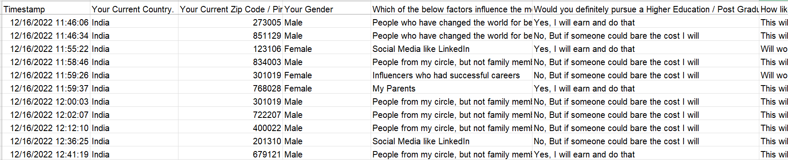

Data after standardization and cleaning:

<https://github.com/gladysnjeri/PortfolioProjects/blob/main/Gen-Z%20Career%20Aspirations%20(Responses)%20(1)%20(1).xlsx>

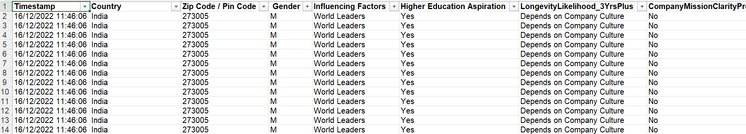

I did the same in SQL:

<https://github.com/gladysnjeri/PortfolioProjects/blob/main/GenZ_Career_Responses.sql>

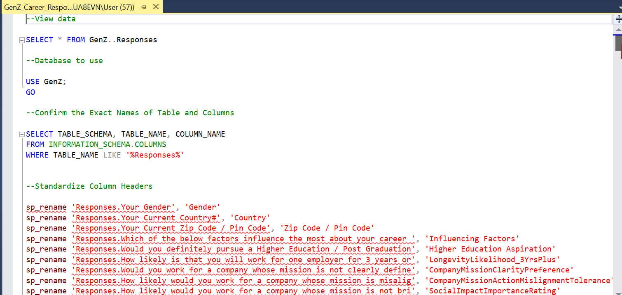

<https://github.com/gladysnjeri/PortfolioProjects/blob/main/GenZ_Career_Responses%20(1).sql>

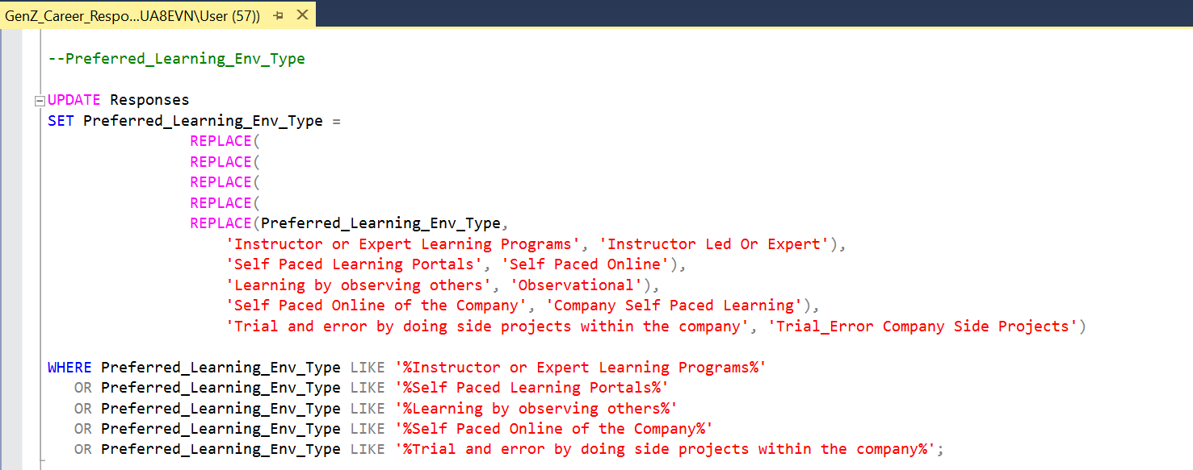

**DATA ANALYSIS**

**Data Analysis in Excel**

For data analysis, I utilized Excel's pivot tables to answer various business questions. This analysis included answering different business questions including identifying the top three influencing factors in career aspirations, the top three preferred work environments, providing a detailed breakdown of higher study aspirations among others. Pivot tables allowed for efficient and comprehensive analysis, facilitating a clear understanding of key trends and insights within the collected data.

<https://github.com/gladysnjeri/PortfolioProjects/blob/main/Gen-Z%20Responses%20(1).xlsx>

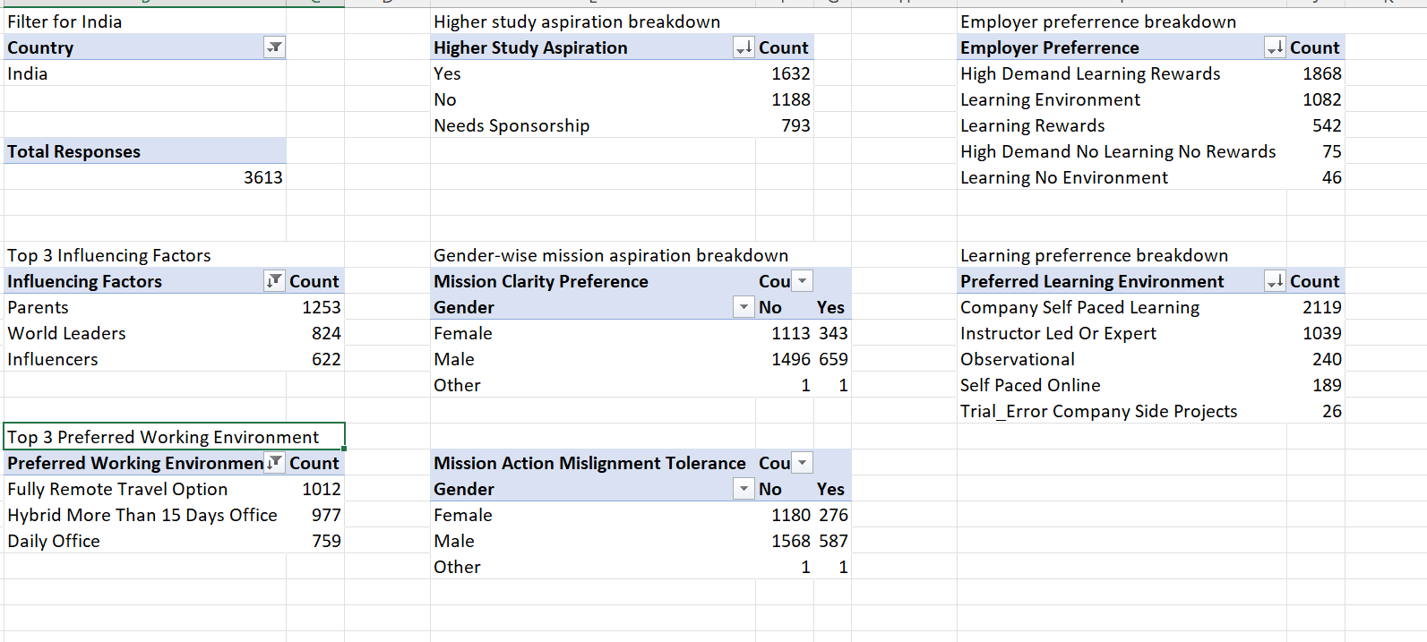

**Advanced Data Analysis in SQL**

In addition to Excel, I conducted further data analysis using SQL. This involved answering key business questions and analyzing the contribution of various factors to Gen-Z career aspirations. The use of SQL allowed for more complex queries and deeper insights into the data, enhancing the overall understanding of the influencing factors and trends in Gen-Z's career preferences.

<https://github.com/gladysnjeri/PortfolioProjects/blob/main/GenZ_Analysis.sql>

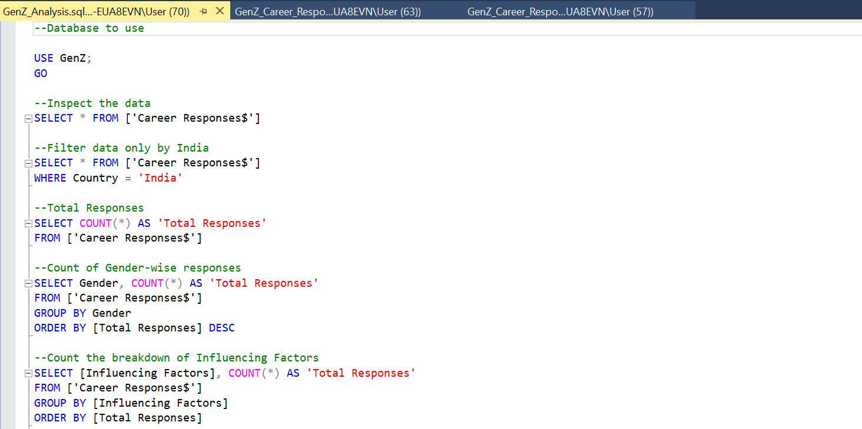

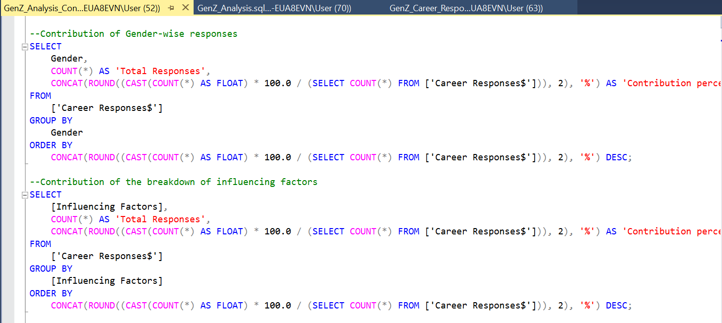

<https://github.com/gladysnjeri/PortfolioProjects/blob/main/GenZ_Analysis_Contribution.sql>

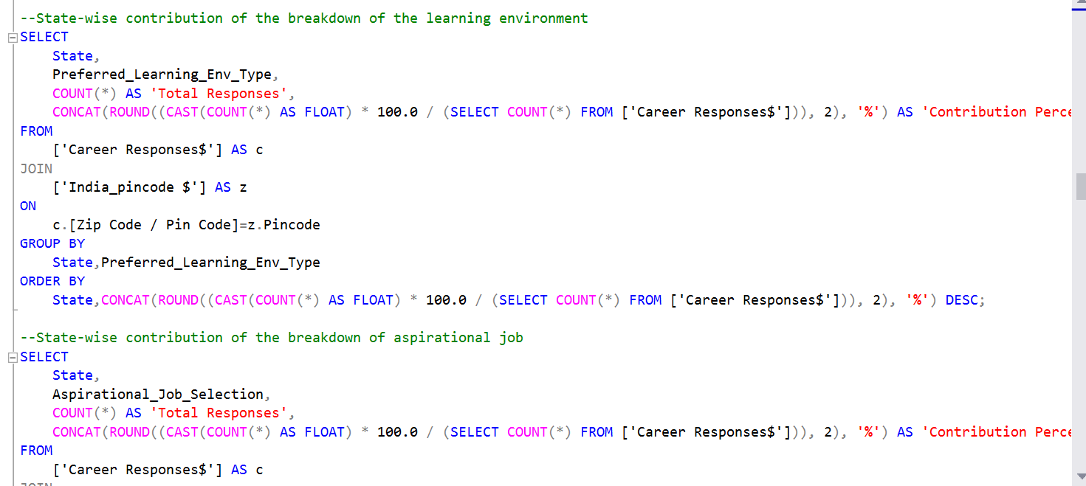

<https://github.com/gladysnjeri/PortfolioProjects/blob/main/Genz_State_Wise_Analysis.sql>

**VISUALIZATION**

For the project, I created dashboards in both Excel and Power BI to visualize the data and derive further insights. These visualizations helped answer key business questions and identify trends and patterns related to Gen-Z's career aspirations. In Power BI, I developed a general dashboard as well as a specialized dashboard focusing on environmental aspirations. These dashboards provided a clear and interactive way to explore the data, making it easier to communicate findings and support decision-making processes.

**Excel Dashboard**

<https://github.com/gladysnjeri/PortfolioProjects/blob/main/Gen-Z%20Dashboard%202.xlsx>

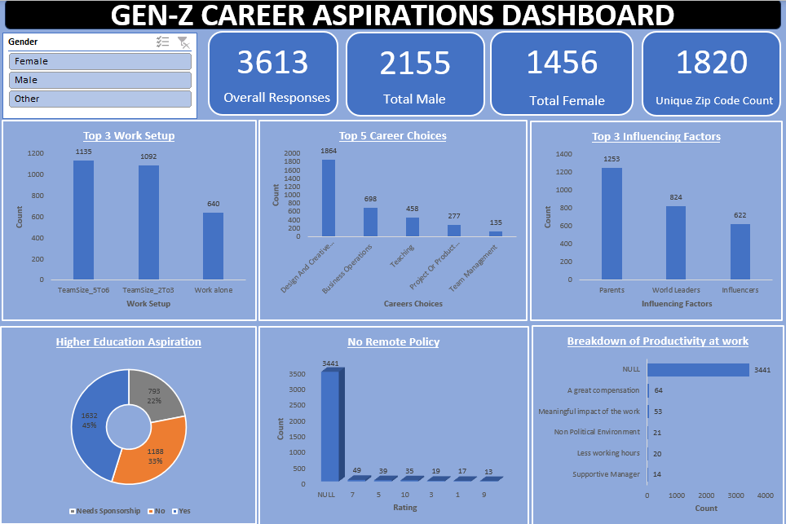

**General Power Bi Dashboard**

<https://github.com/gladysnjeri/PortfolioProjects/blob/main/GenZ%20Dashboard.pbix>

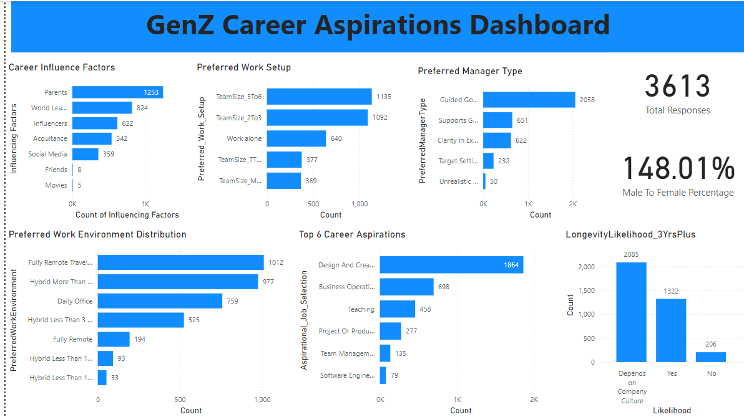

**Focus Area Dashboard in Power Bi**

<https://github.com/gladysnjeri/PortfolioProjects/blob/main/Genz_Dashboard_%20(1).pbix>

